**MESD Documentation LMS-42-Create-and-attend-online-classes**

**Purpose**

To allow for educators to create and facilitate online classes.

**Background**

The MESD LMS will be hosted and housed by the 1Gov 1Citizen platform. This initiative exists to provide services to provide residents of Botswana in a more efficient and effective manner. The MESD LMS will need to be able to host online meetings it will make use of the One Gov Appointment Service to allow for this we make use of a custom activity module plugin named the Synchronous Learning plugin.

**Synchronous Learning Module**

The synchronous learning plugin is a Moodle activity module plugin which makes a request to the appointment service and returns a meeting invite link.

**Setup Process**

Navigate to Site Administration -> Plugins -> Plugin Overview -> Additional Plugins

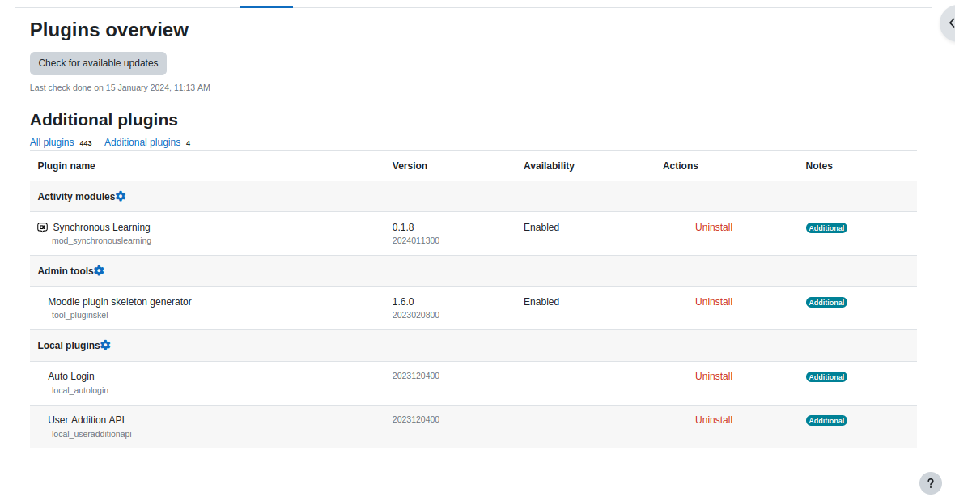

Ensure the synchronous learning plugin is installed if not check notifications in the Site Administration for plugins to be installed.

**How it Works?**

Navigate to your course while in edit mode as an educator click Add an activity or resource

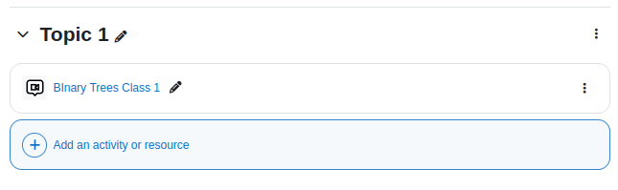

Click video class activity

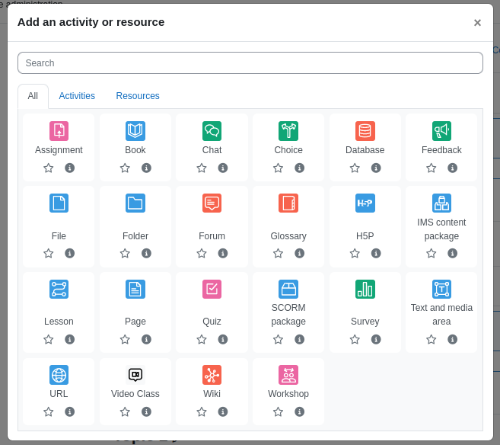

Set the class start time and end time and save changes.

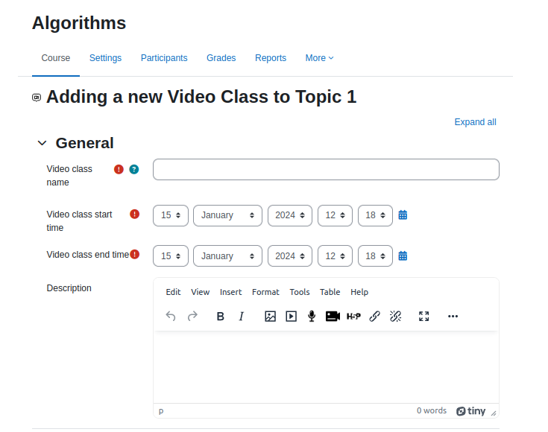

When a user clicks the video class the can click the video class link and attend the meeting.

